Karen L. Desko
1616 20th Avenue Unit B Mobile: 206.913.8318
Seattle, WA 98122 E-mail: kdesko@hotmail.com
__________________________________________________________________________________________

SKILLS SUMMARY
- Manager of own Coaching, Training and Development firm since August 2010
- Skilled designer, deliverer, and analyst of learning and development experiences in the areas of Leadership, People Management, Employee/Manager Relationship, Culture Campaigns, Team Dynamics, Career Development, and Diversity & Inclusion
- Certified coach experienced in coaching individuals, groups and leaders and their teams
- 5 years of experience in the Culture, High Potential Employee and People Manager space at Microsoft
- 20+ years of people management and human resource experience prior to Microsoft

EMPLOYMENT HISTORY
Amplio Consulting, LLC August 2010 - present
Coach, Trainer and Facilitator
Design and deliver customized learning and development solutions, provide group and individual coaching, and deliver existing corporate training programs. Effectively facilitate small and large groups in person and virtually.
- Create and deliver customized change management and team dynamics offerings for companies like Boeing and Microsoft
- Develop and deliver training offerings through MS Bench for High Potential employees on coaching, networking and professional development
- Certified in ‘egonomics’, experienced in Strengthfinder and MBTI
- Certified Professional Co-Active Coach (CPCC)

Microsoft Corporation
Learning and Development Consultant, People and Organizational Capability March 2008 – August 2010
Increased People Manager capability, created Management Excellence, and identified and developed High Potential Employees for WWEPG, CS, and PS. Additionally supported WWLP, OEM, and SMS&P by sharing processes, communications, and training and development offerings. Created, delivered and evaluated course content, executed small and large scale events, secured active senior participation and support, collaborated effectively with HRBPs and POC professionals across segments, contributed to broader Hippies and ME Champs teams by being a passionate voice of the 'customer'. On Boarded, coached and developed People Managers and High Potential employees. Some highlights included:
- Retained 75% of HiPos YOY in FY09
- Hit 60% and 80% Attendance goals for MEFE in FY09 and FY10
- Actively support ExPo events, attend all Superweeks, have 1:1s with all Tier 1 and 2 HiPos
- Co-Chaired ExPo Business Forum with increase in NSAT and overall NSAT of 151 despite 38% budget cut
- Delivered highest scoring People Manager meeting in FY 10
- Developed well received HiPo and People Manager offerings including; Monthly HiPo Round Tables, Monthly People Manager Forums, CVP Unplugged Sessions, Quarterly People Manager Meetings, Learning Circles
Program Manager For Culture, EPG HQ August 2005 – March 2008
Fulfilled a unique role that never existed prior in Microsoft, charged with improving culture and connection within the corporate EPG organization. Reported to EPG’s CVP’s Business Manager, actively participated in business management team activities and enhanced culture through training offerings, connections events, diversity and inclusion activities and MS Poll response. Executed HiPo and ExPo program offerings and increased manager capability through trainings, events and activities. Some highlights include:
- Took a lackluster HiPo program & smoothly integrated it with the successful EXPO program.
- Led the HiPo Team that created the MS Poll Response campaign called “What’s the Deal?” campaign-results included a 9% increase in Work Life Balance scores
- Effectively owned segment business conference for 125+ HiPos for FY 06 and FY 07
- Created new Rewards and Recognition Program and Recruiting Brochure
- Collaborated with the Business Management team on our Quarterly Sync Weeks to deliver Extended Directs Meetings, People Manager Meetings, New Employee Breakfasts and All Hands Meetings
- Provided well received 1:1 Coaching and Team Off Site Facilitation and created and facilitated; Leader Round Tables, Mentor Rings for Females and Ethnic Minorities, Diversity & Inclusion Workshops for Managers, ‘Coaching to Grow’ for People Managers and Field Sales Managers, ‘Manage Your Manager’ for all Employees and ‘EPG HQ 101’ to EPG and broader segment audience

Independent Contractor (while in graduate school) June 2001 – August 2005
Susan Grimes Associates, Washington, DC - Contract EEOC Investigator, Counselor, & Trainer June 2001 – August 2005 Independent contractor as an Equal Employment Opportunity (EEO) Investigator, Counselor and Trainer with 100% acceptance rate of Reports of Investigation at dozens of federal agencies located in Washington DC and in the Mid-Atlantic states. Offered Diversity and Inclusion Trainings with emphasis on the Awareness and Prevention of Sexual Harassment.

George Mason University, Fairfax, VA – Career Counselor Intern during Master’s program May 2005 – August 2005
Provided career coaching and counseling services to undergraduates, graduates and alumnae. Created and facilitated Behavioral Based Interviewing Seminar, University 400-Job Search class, and served as advisor on EEO issues at the Career Center.

Various NGO Organizations, Geneva, Switzerland - Independent Consultant October 2003 – September 2004
International Labor Organization (ILO), United States Mission, World Health Organization (WHO) and Geneva Consulting Group
- Developed and implemented ILO’s groundbreaking program of first ever Sexual Harassment Grievance Procedure at any United Nations organization.
- Acted as resource and provided information on hiring practices and job search skills to Local Employment Advisor at US Mission helping place accompanying spouses of State Department employees on assignment in Geneva.
- Provided training seminars to accompanying spouses on related topics including resume writing, presentation skills, and behavioral based interviewing techniques.
- Acted as consultant to officials at World Health Organization working to re-structure grievance procedures at the WHO.

Aquent, Inc., Chicago, IL – Area Manager July 1999 – June 2001
Managed sales, profit, and operations for $225mm international specialty staffing firm. Created new behavioral interviewing processes and implemented new applicant assessments resulting in 50% decrease in employee turnover and a 35% increase in the fill rate of open positions.

Olsten's of Chicago, Chicago, IL - Vice President December 1993 – July 1999 Held increasingly responsible management roles for $75mm general staffing firm culminating in leadership of sales and service staff of 24 at four branch offices. Serviced multiple client accounts with as many as 800 contract workers on site and consulted client companies on full spectrum of Human Resource issues.

EDUCATION
B.A. Double Major in English Language and Literature, and Rhetoric and Communications Studies, 1984, The University of Virginia, Charlottesville, VA

Completed all coursework, practicum, and majority of internship hours for M.A., Counselor Education, Virginia Polytechnic Institute and State University, Falls Church, VA.

Currently in process for Master’s in Organizational Development, Antioch University, Seattle, WA.

Certified Professional Co-active Coach (CPCC) through the Coaches Training Institute and in membership process for the International Coaching Federation.

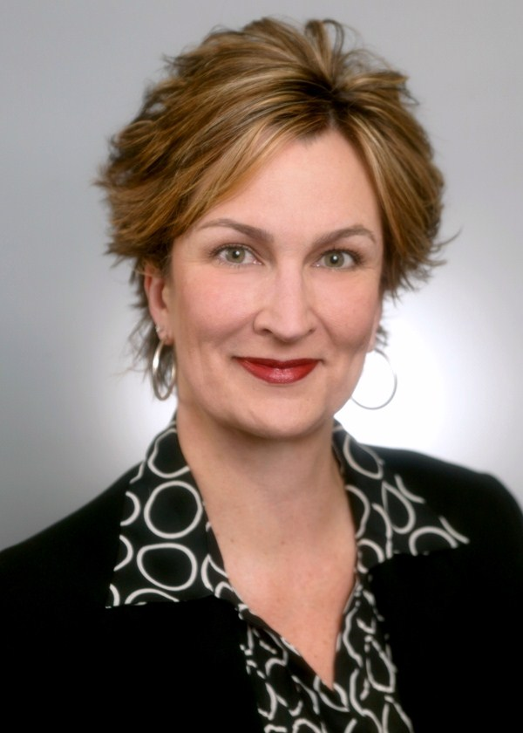

Karen Desko
Amplio Consulting
Coaching, Training, & Development

Karen Desko takes a direct and interactive approach to help her clients shift their perspective and achieve breakthroughs in performance. Her practice is founded on the philosophy that when you increase your awareness, you amplify your impact. She uses a humorous and energetic style to help clients enhance self-awareness, improve self-management and find new ways of thinking, doing, and being.
The foundation of her consulting practice is 20+ years of management experience – full of passion for helping employees connect to their core values, work in authentic ways, and unlock their full potential. She then transitioned into human resources and focused on developing dynamic teams, building excellent leaders, and coaching high potential employees and executives.
As a consultant, Karen has a successful track record of designing and delivering customized learning solutions, increasing leadership capability, and creating high performing teams. She delivers learning and development experiences to individuals and groups ranging in size from 8 – 400 both live and virtually. She is an experienced facilitator and coach whose clients have included Microsoft, Boeing and other organizations in the public and private sectors.
Karen is a certified Professional Co-Active Coach through the Coaches Training Institute, has a Bachelor of Arts from the University of Virginia, and has completed all coursework for her Master’s in Counseling from Virginia Polytechnic Institute and State University. She is currently completing her Master’s in Organizational Development from Antioch University in Seattle and getting certified by the International Coaching Federation.

